**CREATE A CALL OPEN SUMMARY**

**Introduction**

A Call Open Summary is a report you produce from a service call in NAXT. It contains all the critical information from the service call that your technician will need to perform the work:

* customer and equipment details
* details for each segment (problem, scope of work, target time etc)
* service report and SIMS form (for each segment).

The detail in a Call Open Summary comes from your service call. The quality of information on the Call Open Summary is directly related to the structure and data in your service call.

There are four main components to your Call Open Summary; the data on each of these components populates from your service call:

1: service call and equipment information

2: segment overview (for *each* segment)

3: segment details (for *each* segment)

4: service report and SIMS form (for *each* segment).

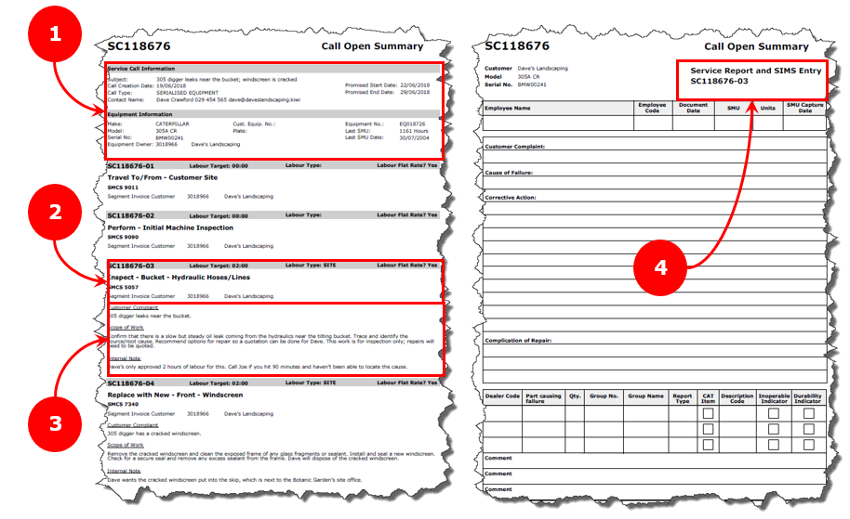

**Where Open Call Summary data comes from**

**Service Call information**

Most of the information is based on what you enter into fields on the service call header when you create the service call. Two fields are pre-populated by NAXT; the date the service call is created and the type of equipment.

1: your service call title.

2: the type of equipment in your service call.

3: the best contact details for your customer for this service call.

4: the start and end date’s you’ve agreed to.

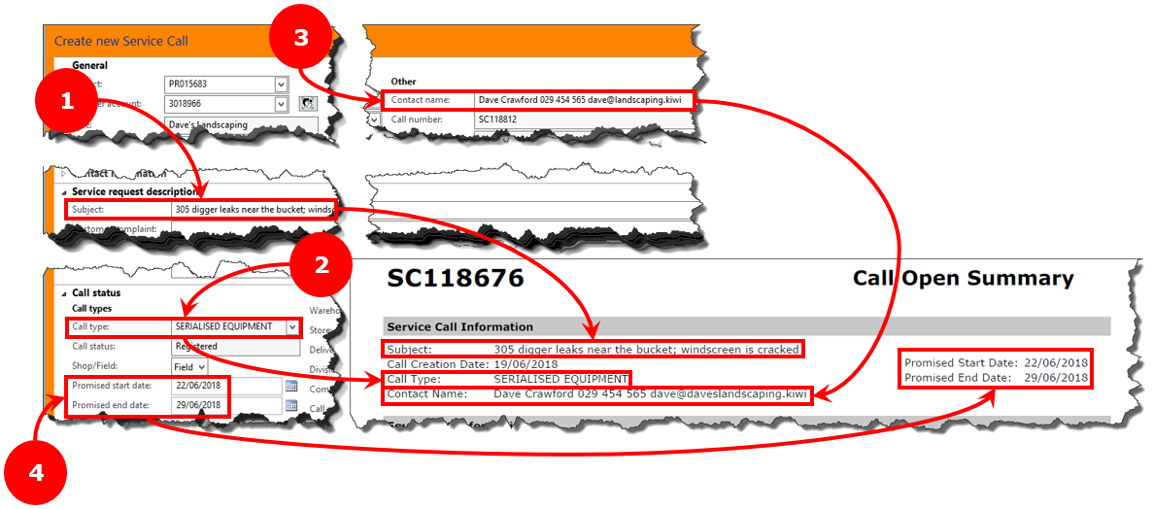

**Equipment information**

This information comes from pre-populated database fields on the service call header, based on the customer and equipment you’ve selected for the service call.

1: your customer account number and name.

2: equipment details.

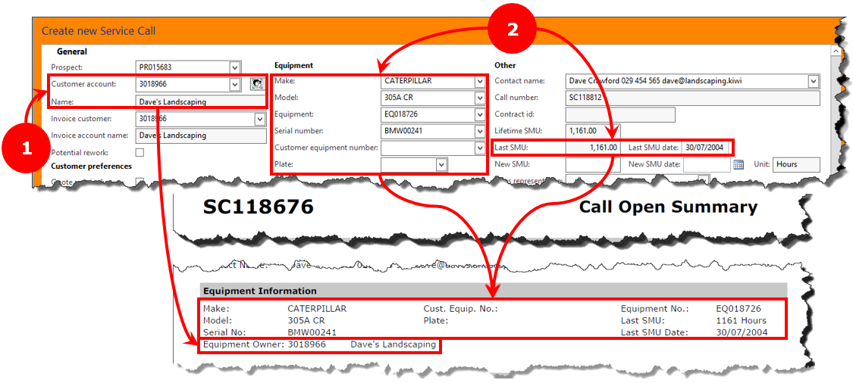

**Segment overview information**

This information comes from the segment; the service call and segment number is auto-generated. All other information is based on how you created the segment.

1: your chosen job and component code (and modifier code) description.

2: your chosen component code.

3: the segment’s invoice account and customer name

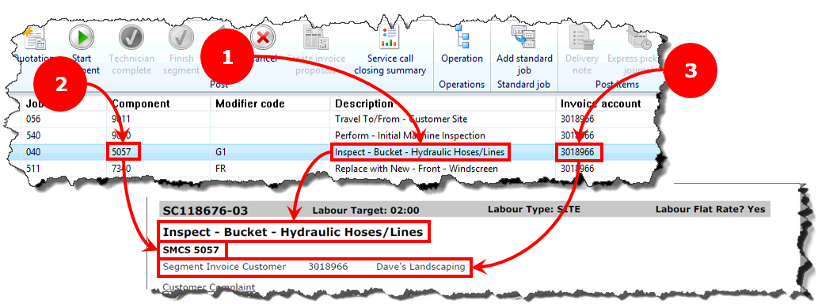

1: the labour type and target time you specified in the ‘Hours’ fast tab.

2: signals if you’ve used a flat rate on the segment’s labour.

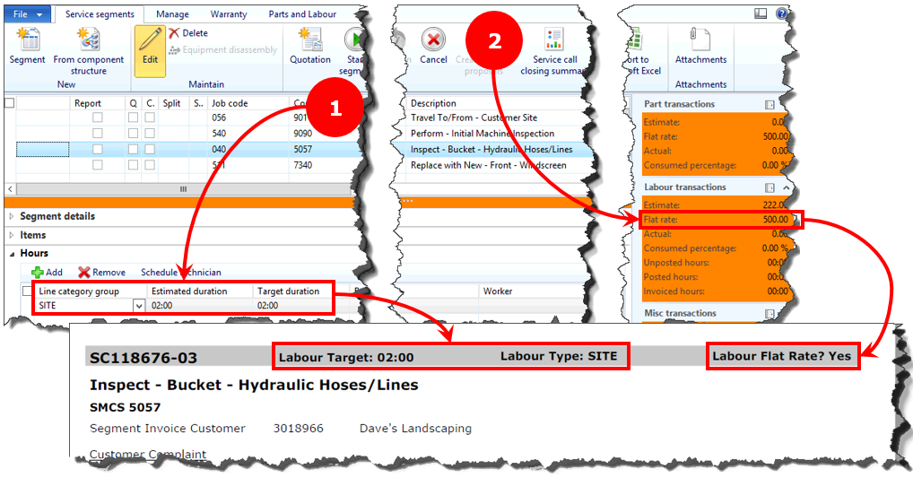

**Segment detail information**

This information comes from the three fields in the ‘Messages’ tab of each segment’s ‘Details’ fast tab. The detail sets out the:

1: problem the segment will resolve.

2: steps (scope of work) your technician will take to correct the problem.

3: incidental information that could be helpful for your technician.

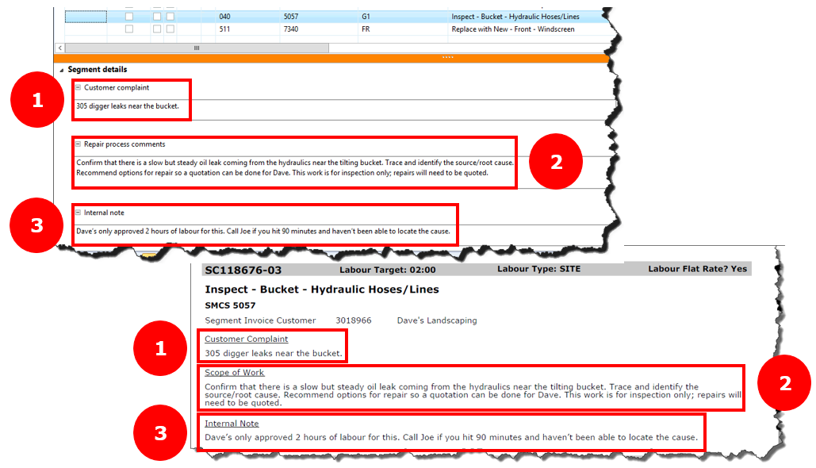

**Create a Call Open Summary**

**Step 1: Select your service call**

1A: check you’re in the service module.

1B: expand the ‘Common’ and ‘Service call’ menus.

1C: select ‘All service calls’.

1D: locate and select your service call.

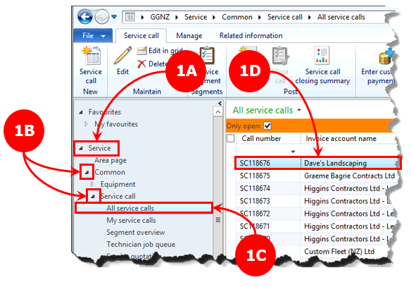

**Step 2: Create your Open Call Summary**

2A: select the ‘Related information’ ribbon tab.

2B: Select the ‘Open summary’ function button; the ‘Open summary’ window will pop up.

2C: Select ‘OK’; a PDF will open.

2D: print and/or save the PDF.

